Computer Language Coding Concepts

Add in a Diagram
The concept of Add is explained in the article Add. The current article demonstrates its expression in a diagram.

The system member Add is part of the system interface of a related list and is displayed in a diagram as follows:

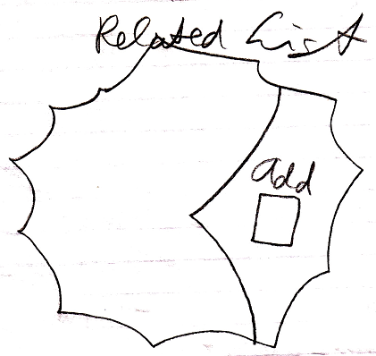

See also: System Objects, Add

Author & Copyright: Jan-Joost van Zon Date: July 18, 2008 – July 18, 2008 Location: Oosterhout, The Netherlands Status: Finished

